Project 4

Doing a Equi Join between Employee and Department, looking for only the values that have to do with Accounting.

SELECT *

FROM WP_DEPARTMENT, WP_EMPLOYEE

WHERE WP_EMPLOYEE.Department = 'Accounting'

AND WP_DEPARTMENT.DepartmentName = 'Accounting';

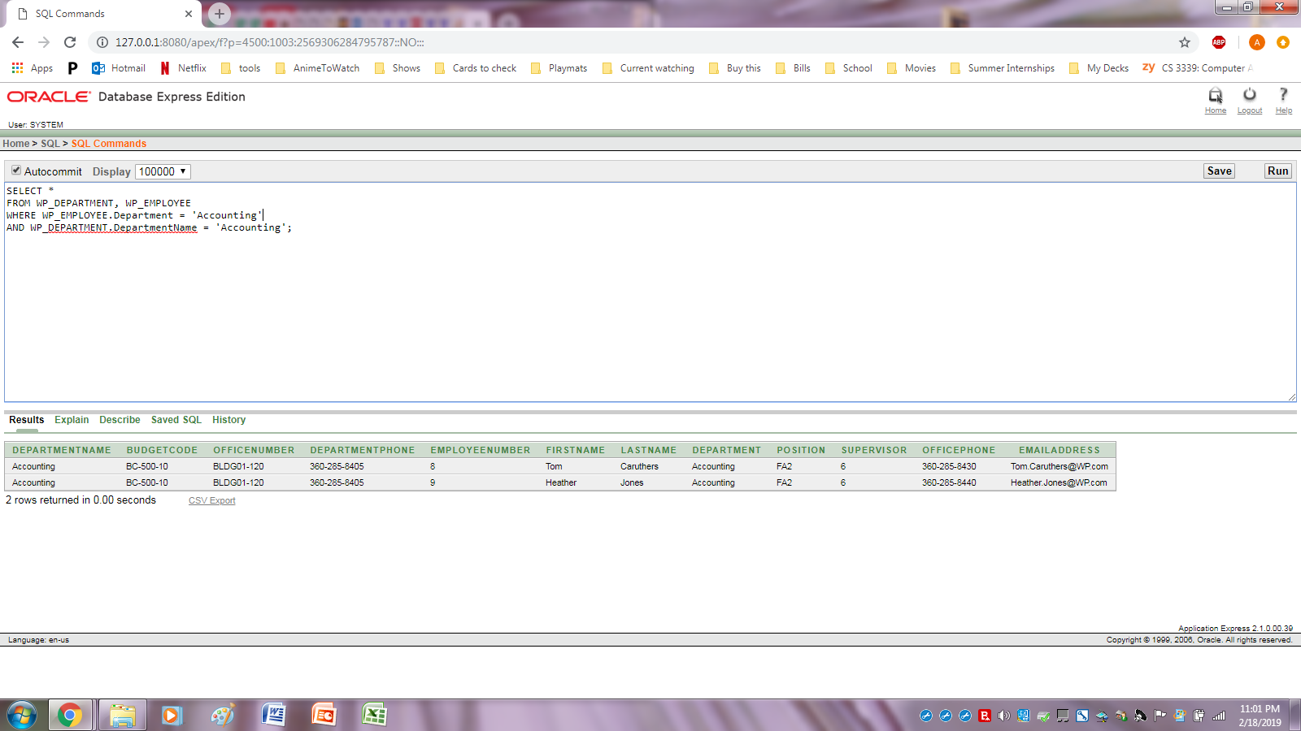

Natural Joining WP_PROJECT and WP_ASSIGNMENT.

SELECT *

FROM WP_PROJECT

NATURAL JOIN WP_ASSIGNMENT;

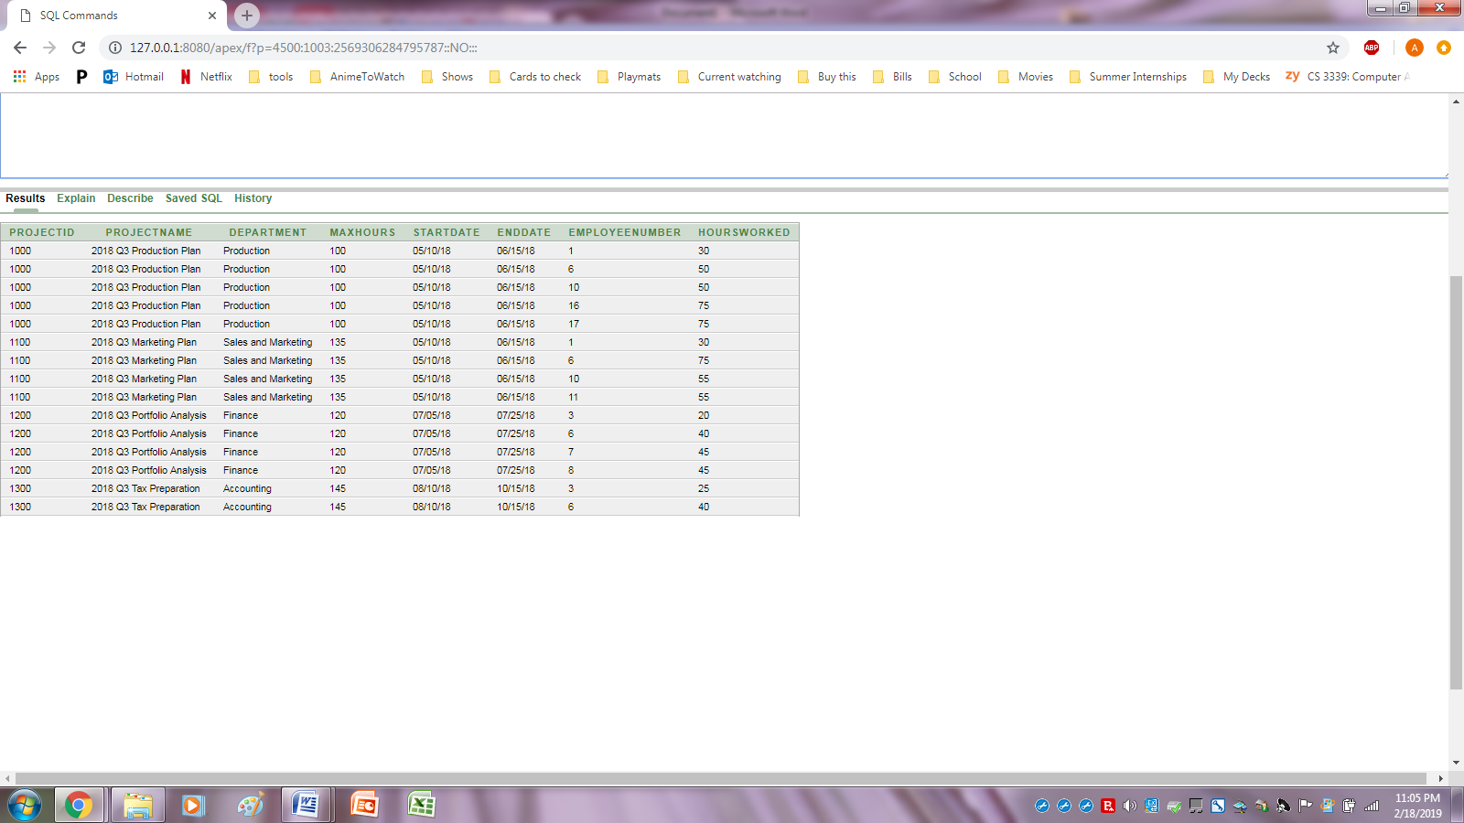

Doing a Subquery from Department's involving Production, I'm getting the names of the employees that work in that department

SELECT FirstName, LastName

From WP_EMPLOYEE

WHERE Department IN

(SELECT DepartmentName

FROM WP_DEPARTMENT

WHERE DepartmentName = 'Production')

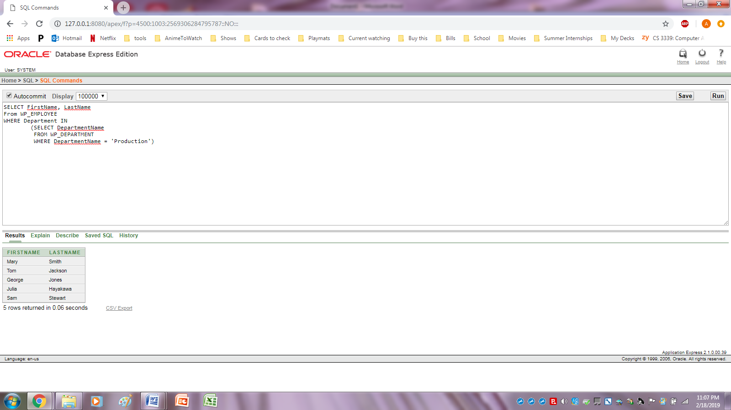

Calculating the total number of hours worked on each project

SELECT ProjectID, SUM(HoursWorked) AS TotalWorkHours

FROM WP_Assignment

GROUP BY ProjectID;

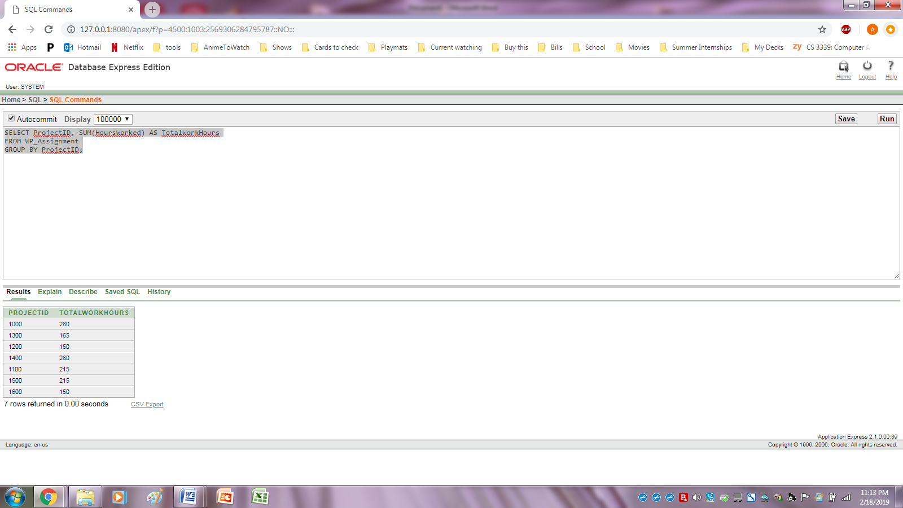

Created a view of all the employees (w/ positions) arranged by their last name.

CREATE VIEW Employees AS

SELECT LastName AS Last,

FirstName AS First,

Position AS Position

FROM WP_EMPLOYEE

ORDER BY Last;

SELECT *

FROM Employees;

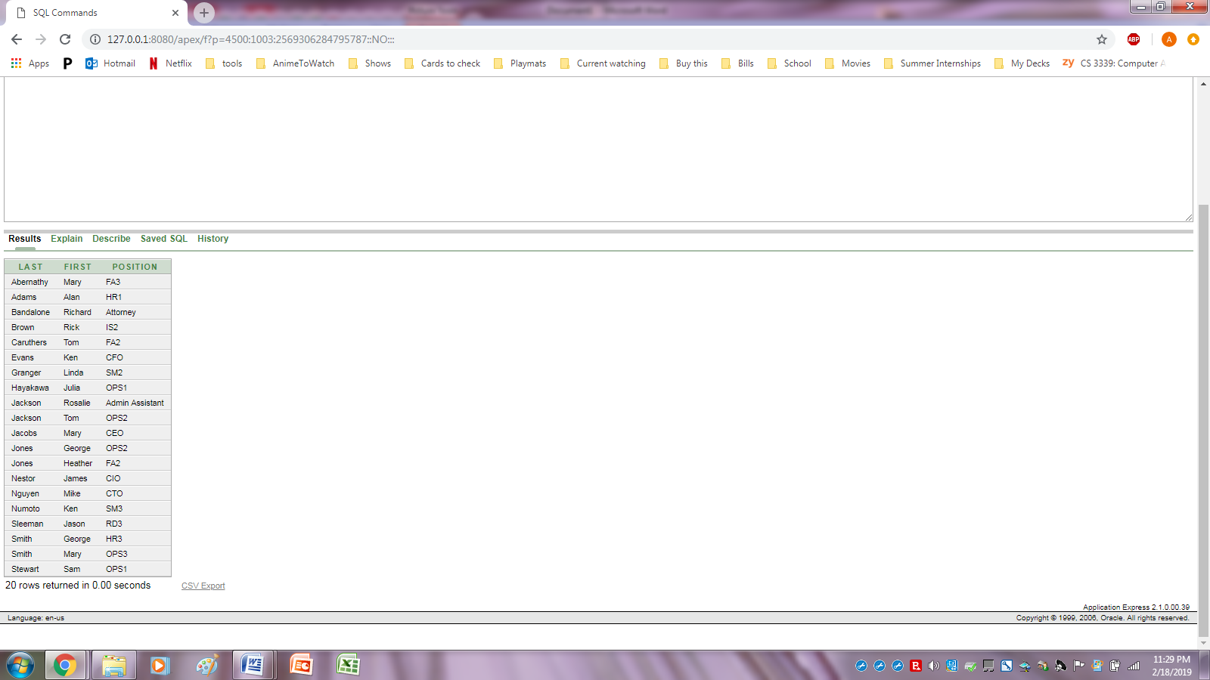

Getting a table with the count of how many people are working on each project

SELECT ProjectID, COUNT(EmployeeNumber) AS PeopleOnProject

FROM WP_ASSIGNMENT

GROUP BY ProjectID

ORDER BY ProjectID;

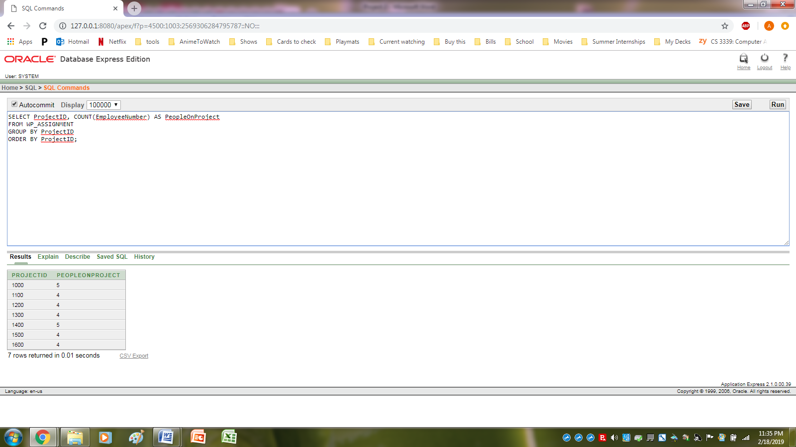

Cross joined Project and Department

SELECT *

FROM WP_PROJECT, WP_DEPARTMENT;

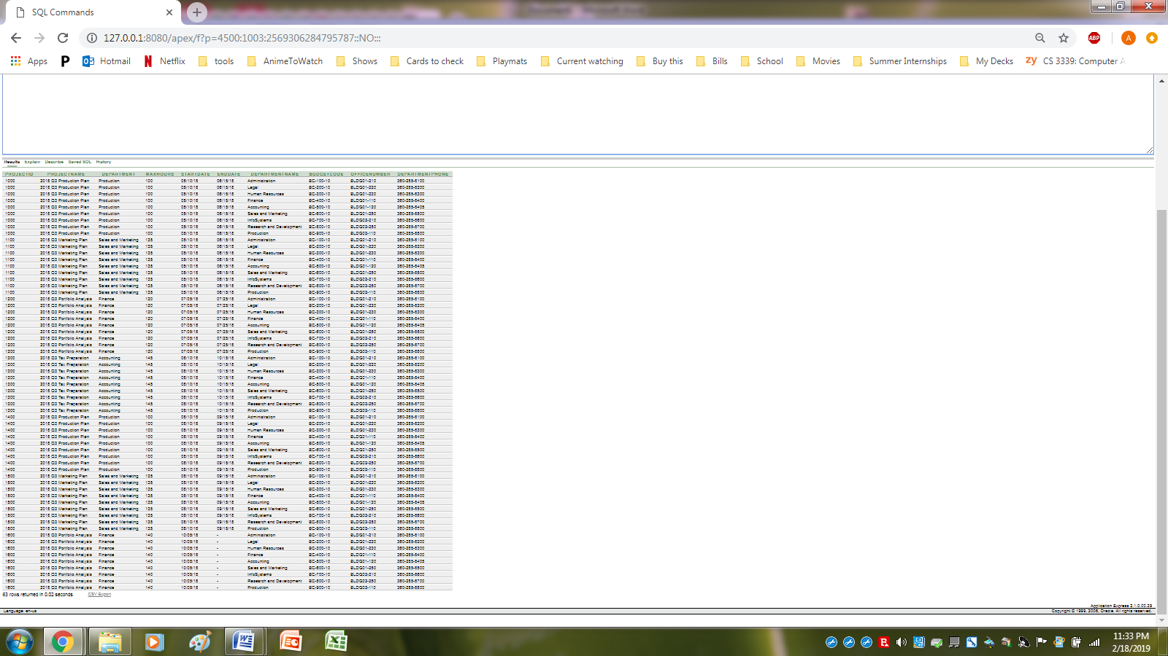

Getting the number of people that work in each department, arranged by department.

SELECT Department, COUNT(Department) AS PeopleInDepartment

FROM WP_EMPLOYEE

GROUP BY Department

ORDER BY Department;

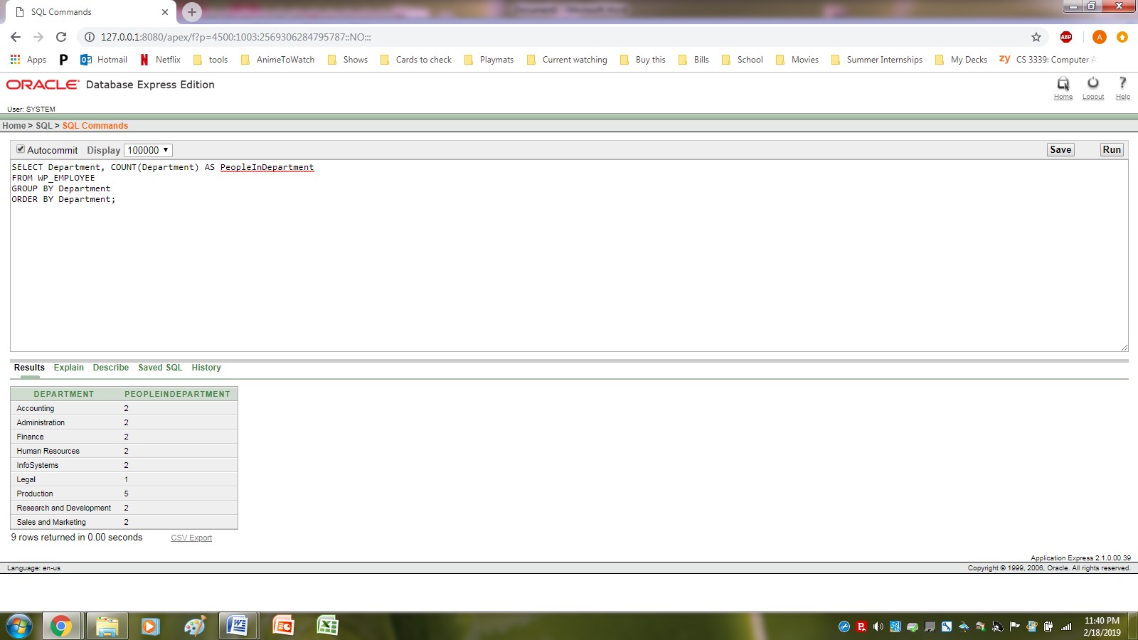

E/R Model

